Unit 2 Assignment 2: Exploratory Data Analysis of Prostate Cancer Study Dataset

DS Chin

University of Maryland Global Campus

DATA 645

Dr.Firdu Bati

March 24, 2026

Introduction
Prostate cancer is one of the most prevalent forms of cancer among men worldwide. In the United States, it is estimated that approximately one in eight men will be diagnosed with the disease during their lifetime. As a male in my mid-40s, this is a health milestone I have personally begun to navigate, and that connection is what initially drew my attention to this specific dataset.
For medical context, the prostatic capsule is a fibrous shell that surrounds the gland. If cancer cells breach this boundary, the disease is staged as "locally advanced," which significantly increases the risk of metastasis. Detecting this penetration is vital for determining the appropriate treatment—such as deciding between surgery or radiation. Because physical examinations like the Digital Rectal Exam (DRE) often fail to detect early penetration, clinicians rely on a combination of biomarkers, such as Prostate-Specific Antigen (PSA) levels and cellular grading systems like the Gleason score, to assess risk. This dataset provides a critical window into these clinical variables.
The primary objective of this assignment is to perform a thorough Exploratory Data Analysis (EDA) to transform this information into a high-quality, workable resource. As the adage "garbage in, garbage out" suggests, the EDA process allows the analyst to ensure the integrity of the data within the context of its purpose and verify that the underlying variables are consistent, accurate, and clinically relevant before moving toward any formal predictive modeling. Supporting the primary objective, having the proper context and background information of what the data represent is a critical component of conducting an EDA. This report will outline the steps necessary to conduct a proper EDA on the dataset pros.csv.

Exploratory Analysis
The context of the data represents patients who underwent surgery or biopsy for prostate cancer with the primary goal predicting capsular penetration—whether the tumor has spread through the prostate's outer lining. As stated in the sources GitHub page, this data was originally compiled and analyzed by researchers in the field of urology and has since become a standard teaching dataset in the field of statistics.

Utilizing basic functions like df.shape, df.columns, df.types, and df.describe() we are given the basic information: 380 rows and 9 columns; names of the columns, types of data, and basic summary and math statistics (Figure 1). Before continuing on in the EDA process, I felt it was imperative to know the context of what this dataset represents. Through additional research into this topic I was able to determine the nature of these variables which can be broken down to two broad categories: demographical information (age, race) and clinical findings (physical exam results, lab tests, and pathological assessments). Please refer to the Appendix (Figure 2) for a more comprehensive explanation of the variables, however, the following table provides a quick overview of the variables:

Variable | Description | Meaning of Values
ID | Identification Code | Unique number assigned to each of the 380 patients.
CAPSULE | Tumor Penetration | 0 = No penetration; 1 =Penetration (the tumor has broken through the capsule  Target Variable
AGE | Patient Age | The patient's age in years
RACE | Patient Race | 1 = Caucasian/White; 2 = African-American/Black
DPROS | Digital Rectal Exam (DRE) | Results of the physical exam of the prostate: 1 = No Nodule, 2 = Left Nodule; 3 =Right Nodule; 4 = Bilobar Nodule.
DCAPS | Capsular Involvement | Detection of capsular involvement during the rectal exam: 1 = No, 2 = Yes.
PSA | PSA Value | Prostate-Specific Antigen level in the blood (measured in mg/mL).
VOL | Tumor Volume | The volume of the tumor as measured by ultrasound (in cm3).
GLEASON | Gleason Score | A scoring system (0–10) used to grade the aggressiveness of the cancer cells under a microscope.

In addition to the initial insights provided by standard exploratory functions (like df.shape, df.describe, etc) visualizations added significant depth to my understanding of the clinical data. I organized these into three functional categories to best highlight the patterns found within the dataset:
- Distribution of Numerical Frequencies: Histograms were employed to visualize the distribution of Tumor Volume (VOL) and Prostate-Specific Antigen (PSA) levels, while a horizontal bar graph was used to detail the frequency of the Digital Rectal Exam (DPROS) results. These visualizations are essential for identifying the shape of the clinical data. For variables like PSA and VOL, the histograms revealed a general positive skew, where most patients cluster at lower values while a few extreme cases pull the average upward. Additionally, the VOL also showed a very large number of participants had ‘0’ cm3. (Figure 3)
- Categorical Composition: Pie charts were utilized to illustrate the proportions within the participant pool, specifically for the race of the participants (RACE), the Capsular Involvement profile (DCAPS), and the overall Tumor Penetration profile (CAPSULE). Using pie charts for these variables provides an immediate sense of class balance. In medical datasets, it is vital to know if the sample is heavily weighted toward one group. For example, the RACE pie chart reveals the diversity (or lack thereof) within the study, which impacts how generalizable the findings are. Similarly, the CAPSULE and DCAPS charts show the prevalence of the condition itself; if the "Penetration" group is much smaller than the "No Penetration" group, the data is considered "imbalanced," which requires specific handling during the data preparation phase to ensure the final analysis remains objective. (Figure 4)
- Statistical Range and Variance: Boxplots were used to visualize the mathematical distribution, median, and variance for both the AGE category and the GLEASON scores. Boxplots provide a higher level of mathematical rigor by displaying the interquartile range (IQR) and identifying potential outliers. For the AGE category, the boxplot helps confirm that the study is focused on a specific demographic (typically older males), while the whiskers of the plot highlight any unusually young or old participants who might be statistical anomalies. For GLEASON scores, the boxplot is particularly useful for seeing the "typical" severity of cancer in this group; it allows us to see where the middle 50% of the scores lie, providing a clear visual representation of the dataset's central tendency and the consistency of the pathological grading. (Figure 5)

Preprocessing
Perhaps due to the nature of this dataset’s source—a "standard teaching dataset in the field of statistics"—the need for extensive data cleaning and reduction was minimal. Utilizing the df.isna().sum() function (Figure 6) to calculate total nulls, it was determined that only four values were missing across the entire dataset. By synthesizing information gathered from the df.dtypes and df.describe() functions, it was safe to infer that values remained consistent within their respective categories and outliers were logically accounted for. For instance, the data remained clean of entry errors; there were no string values like “white” appearing in the numerical RACE column, nor were there impossible values like “-15” for a GLEASON score, which adhered to its 0–10 parameter range.
Given that the missing data consisted of only three entries from RACE (a categorical identifier) and one from VOL (a continuous volume measurement), there was no compelling need for complex data imputation or other special treatments. With such a negligible missingness rate (roughly 1% of the 380 records), the risk of introducing statistical bias through simple exclusion is extremely low. I recommend either performing a "listwise deletion" (omitting the incomplete records) or, if maintaining the full sample size is critical, substituting the missing VOL value with the column mean .mean() and .fillna() (figure 7). For the categorical RACE entries, a simple "Unknown" placeholder would suffice to preserve the integrity of the remaining attributes without distorting the overall distribution.
Additionally, with the dataset containing only 380 rows (or objects), the need for downsampling to improve processing speed was non-existent. The structural simplicity of having only nine columns (or attributes)—one of which is a redundant ID code—ensures that complexity and noise are not significant factors in the analysis. The only foreseeable exception would be the potential need for stratified sampling to address the heavy imbalance within the RACE variable. With a distribution of 341 "White" entries (approximately 90%) versus only 36 "Black" entries (approximately 10%), this disparity could potentially skew the analysis or lead to underrepresentation of the minority group in certain statistical models.
Because the variables are few and clinically distinct, applying dimensionality reduction techniques like Principal Component Analysis (PCA) would be counterproductive. Transforming these clear, high-value variables into abstract principal components would obscure the direct relationship between factors like Age and Tumor Volume, making the results harder to interpret without offering any gain in computational efficiency.
Regarding data transformation, the clinical relevance of the variables dictated a conservative approach to activities such as smoothing and normalization. Smoothing and aggregation were deemed unnecessary, as the 380 observations provided a clear enough signal without the risk of significant random noise. Furthermore, normalization (scaling values to a range of 0 to 1) was bypassed to preserve the original units of measurement—such as VOL in cm3 and AGE in years—which are more intuitive for clinical interpretation than abstract coefficients. Feature construction was also limited, as the existing attributes like the GLEASON score and PSA levels already carry high standalone predictive value. Lastly, while discretization (binning continuous data into categories) was considered for tumor volume, the decision was made to keep it as a continuous variable to maintain the granular detail required for accurate boxplot and histogram analysis.

Conclusion
The exploratory analysis of this prostate cancer study dataset reveals a clinical profile primarily composed of older males, where the majority of participants exhibit organ-confined tumors. Key findings include a significant positive skew in both PSA levels and Tumor Volume (VOL), indicating that while most patients present with lower clinical markers, a smaller subset of extreme cases significantly drives the dataset's average upward. Furthermore, the analysis of GLEASON scores and DPROS findings highlights a clear progression of disease severity, with intermediate to high-grade scores serving as a critical indicator for potential capsular penetration. These insights confirm that the variables provided—despite the dataset’s simplicity—offer a robust foundation for understanding the clinical risk factors associated with locally advanced prostate cancer.
Several limitations were identified during this preliminary investigation that warrant some consideration. A primary constraint is the heavy demographic and categorical imbalance observed within the dataset, particularly regarding the RACE variable. With approximately 90% of the entries identifying as "White," this lack of diversity significantly limits the generalizability of the findings across broader, more ethnically diverse populations. This disparity suggests that the clinical correlations observed here may not be fully representative of the disease's behavior or progression in other demographic groups.
While the provided attributes are of high clinical value, the dataset lacks other essential confounding factors—such as patient family history, genetic markers, or previous treatment interventions—that would be necessary to provide a more comprehensive and nuanced prediction of capsular involvement. These factors combined suggest that while the analysis is a strong foundational exercise, its conclusions should be applied with an understanding of these inherent structural boundaries.
In conclusion, the 'pros.csv' dataset presented minimal challenges in regards to what one typically faces when encountering datasets in need of thorough exploratory analysis, such as extensive missing values or excessive noise. However, this inherent cleanliness did not negate the necessity of the EDA process. Through systematic visualization and statistical auditing, the analysis successfully uncovered critical skews in PSA and Tumor Volume that would have otherwise remained hidden in a simple mean-based summary. By establishing these clinical baselines and identifying key demographic imbalances, this EDA has fulfilled its primary objective: transforming a static table of clinical observations into a refined, reliable, and well-understood resource ready for the next stages of predictive modeling and risk assessment.

References

American Cancer Society. (2023, November 22). Screening tests for prostate cancer. https://www.cancer.org/cancer/types/prostate-cancer/detection-diagnosis-staging/tests.html

Bostwick, D. G., Qian, J., Bergstralh, E., Dundore, P., James, D., Myers, R. P., & Oesterling, J. E. (1996). Prediction of capsular perforation and seminal vesicle invasion in prostate cancer. The Journal of Urology, 155(4), 1361–1367. https://doi.org/10.1016/S0022-5347(01)66267-0

Han, J., Kamber, M., & Pei, J. (2011). Data mining: Concepts and techniques (3rd ed.). Elsevier Science.

Mulla, R. (2021, December 31). Exploratory data analysis with Pandas Python [Video]. YouTube. https://www.youtube.com/watch?v=xi0vhXFPegw

Prajwal, C. N. (2022, August 3). EDA - exploratory data analysis: Using Python functions. DigitalOcean. https://www.digitalocean.com/community/tutorials/exploratory-data-analysis-python

Simplilearn. (2018, May 15). Data science with Python | Python for data science | Python data science tutorial | Simplilearn [Video]. YouTube. https://www.youtube.com/watch?v=mkv5mxYu0Wk

Appendix

Figure 1
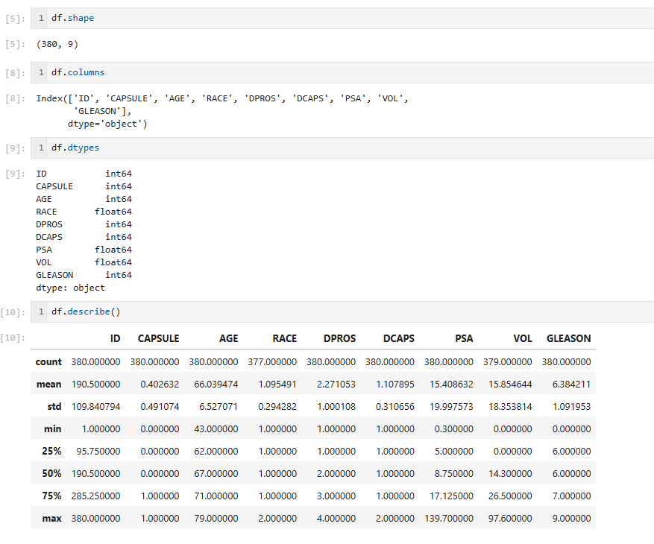

Figure 2
Reference to medical testing terms:
Variable | Name | Description | Codes/Values
1 | ID | Identification Code | 1 - 380
2 | CAPSULE | Tumor Penetration of Prostatic Capsule | 0 = No Penetration  1 = Penetration
3 | AGE | Age | Years
4 | RACE | Race | 1= White  2 = Black
5 | DPROS | Results of the Digital Rectal Exam | 1 = No Nodule  2 = Unilobar Nodule (Left)  3 = Unilobar Nodule (Right)  4 = Bilobar Nodule
6 | DCAPS | Detection of Capsular Prostatic  Specific Involvement in Rectal Exam | 1 = No  2 = Yes
7 | PSA | Prostatic Specific Antigen Value | mg/ml
8 | VOL | Tumor Volume Obtained from Ultrasound | cm3
9 | GLEASON | Total Gleason Score | 0 - 10

Tumor Penetration of Prostatic Capsule refers to whether a prostate cancer has grown beyond the outer boundary of the prostate gland.
- No Penetration: The tumor is "organ-confined," meaning it is entirely contained within the prostate gland.
- Penetration: The tumor has broken through that outer layer and started invading the surrounding periprostatic fat or connective tissue.

Results of the Digital Rectal Exam present four categories that have a natural progression of severity or extent.
- 1 = No Nodule: The prostate feels smooth and normal. This is your "baseline" or "control" group.
- 2 = Unilobar Nodule (Left): A firm lump is felt, but it is restricted to the left lobe of the prostate only.
- 3 = Unilobar Nodule (Right): A firm lump is felt, but it is restricted to the right lobe of the prostate only.
- 4 = Bilobar Nodule: Firm lumps or abnormalities are felt on both the left and right sides of the gland.

Detection of Capsular Prostatic Specific Involvement in Rectal Exam is a clinical examination used to detect physical irregularities in the prostate gland. The presence and extent of these irregularities serve as a primary indicator of whether a tumor is likely to have penetrated the prostatic capsule.
- No (Level 1): Indicates no nodules were felt; the prostate surface is smooth, suggesting the tumor is likely still contained within the gland.
- Yes (Levels 2–4): Indicates the detection of nodules (unilobar or bilobar); these irregularities suggest an increased probability that the tumor has grown enough to breach the capsule.
Prostatic Specific Antigen (PSA) is a protein produced by the prostate, and in this dataset, a higher value acts as a key continuous predictor for tumor progression.
- Normal: 0 to 4 ng/mL.
- Borderline/High: 4 to 10 ng/mL
- Very High: Above 10 ng/mL.

Tumor Volume Obtained from Ultrasound represents the estimated size of the tumor in cubic centimeters (cm3) as measured by a Transrectal Ultrasound (TRUS).

Volume Level (cm3) | Category | Clinical Implication
< 0.5 | Very Small | Very low probability of capsular penetration; often considered "clinically insignificant."
0.5 – 4.0 | Moderate | The "typical" range for localized tumors; penetration risk increases as volume nears 4.0.
4.0 – 10.0 | Large | High suspicion of capsular involvement; tumor is likely taking up a significant portion of the gland.
> 10.0 | Very Large | Extremely high probability that the tumor has breached the capsule or involved surrounding structures.
The Total Gleason Score is a clinical measure of cancer aggressiveness based on the microscopic appearance of prostate tissue, calculated by summing the two most common cell patterns observed.

Score | Grade | Clinical Interpretation
≤ 6 | Low Grade | Cells look relatively "normal"; cancer is slow-growing and usually contained.
7 | Intermediate | A "tipping point" score; carries a moderate risk of capsular penetration.
8 – 10 | High Grade | Cells are highly irregular; indicate an aggressive tumor with a very high probability of being non-contained.

Figure 3
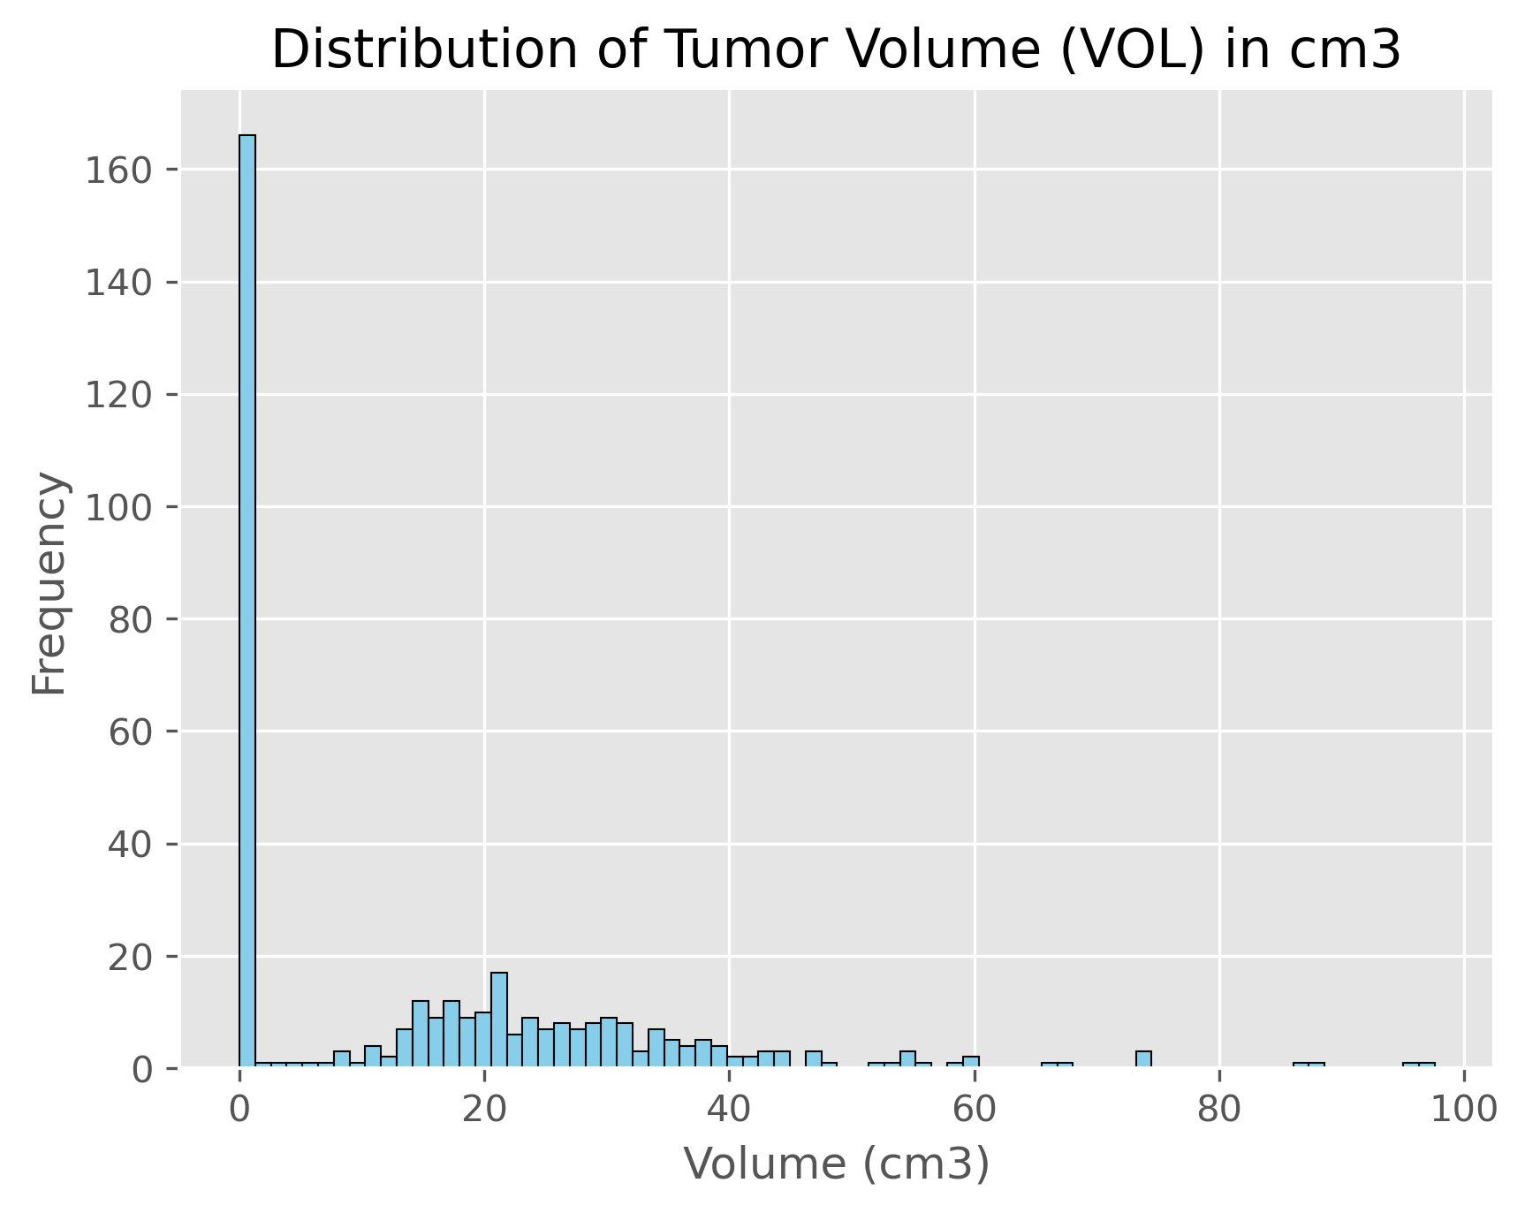
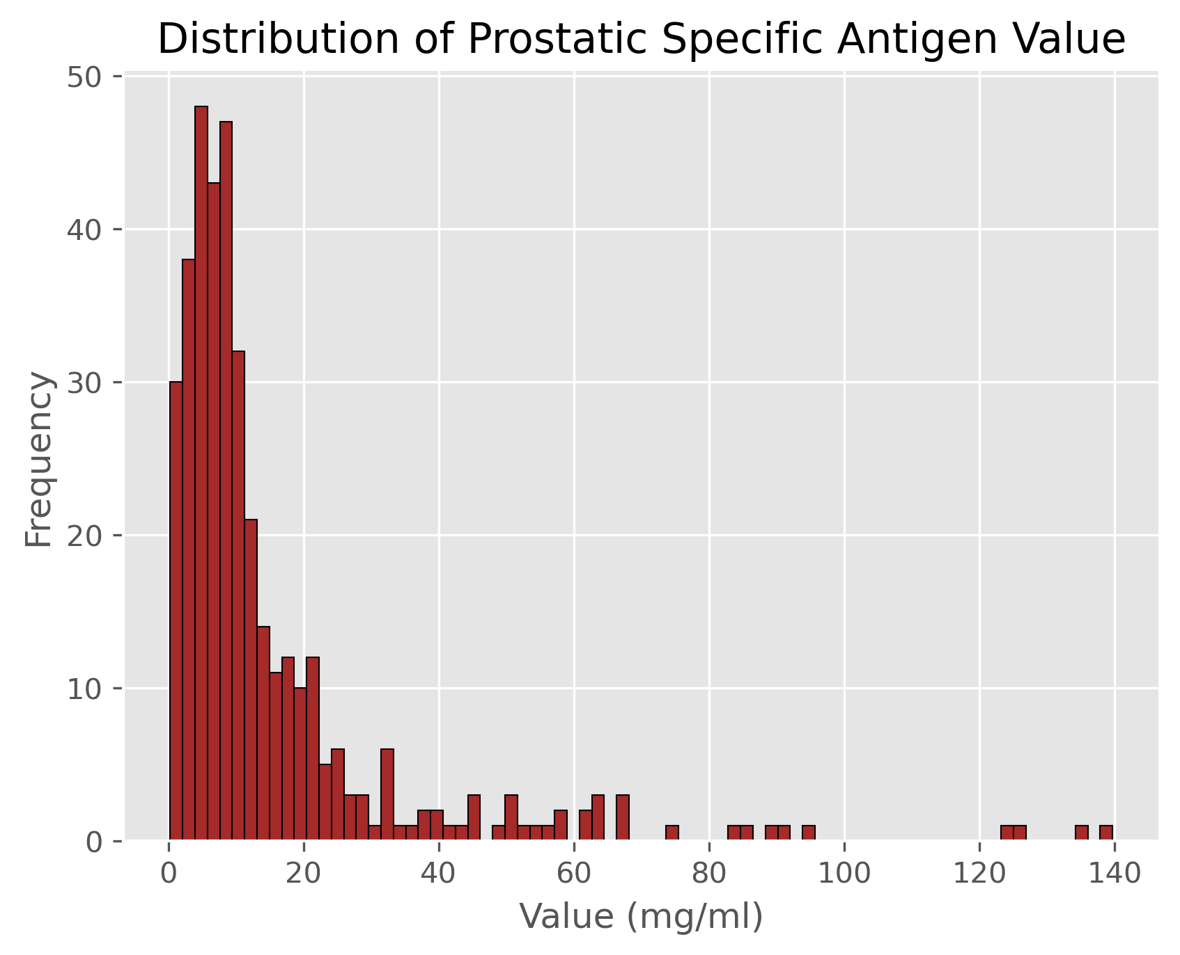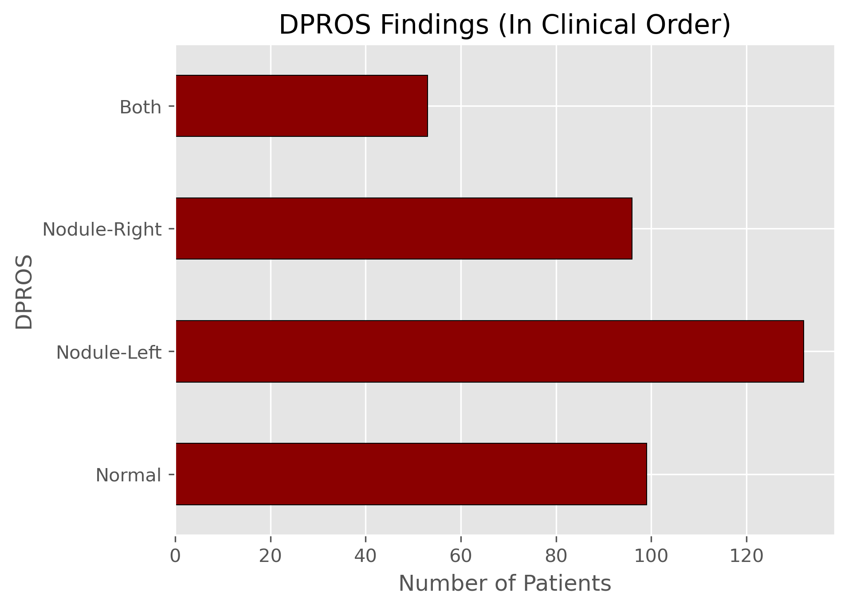
Figure 4

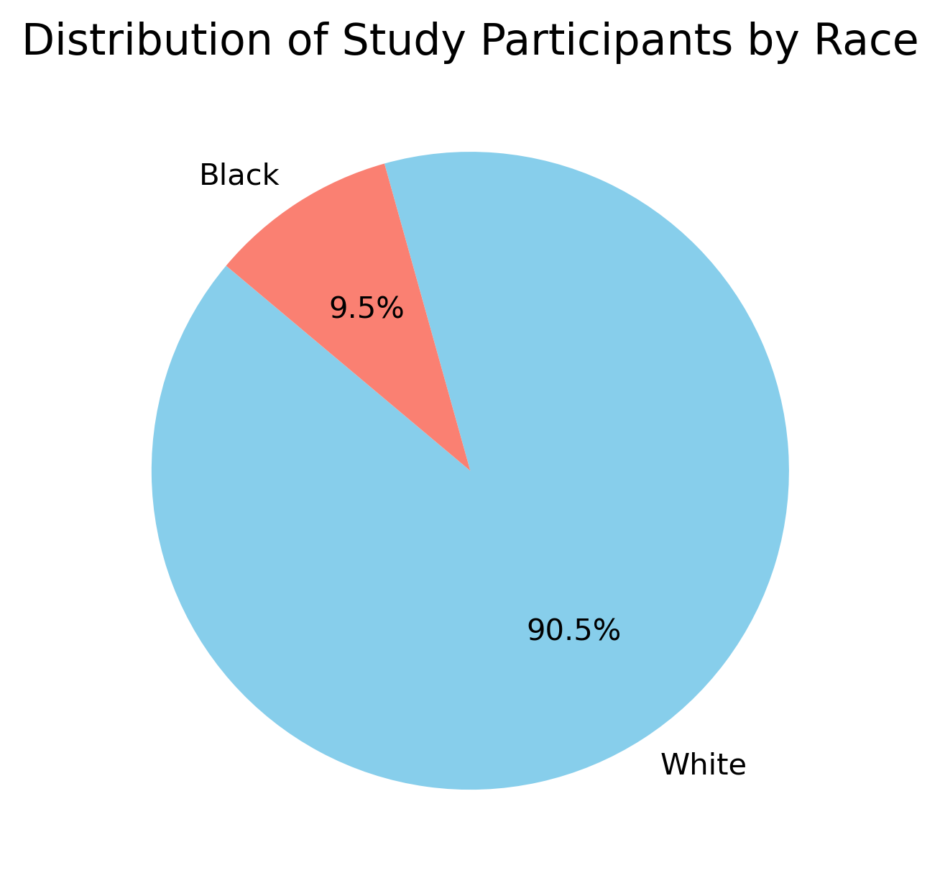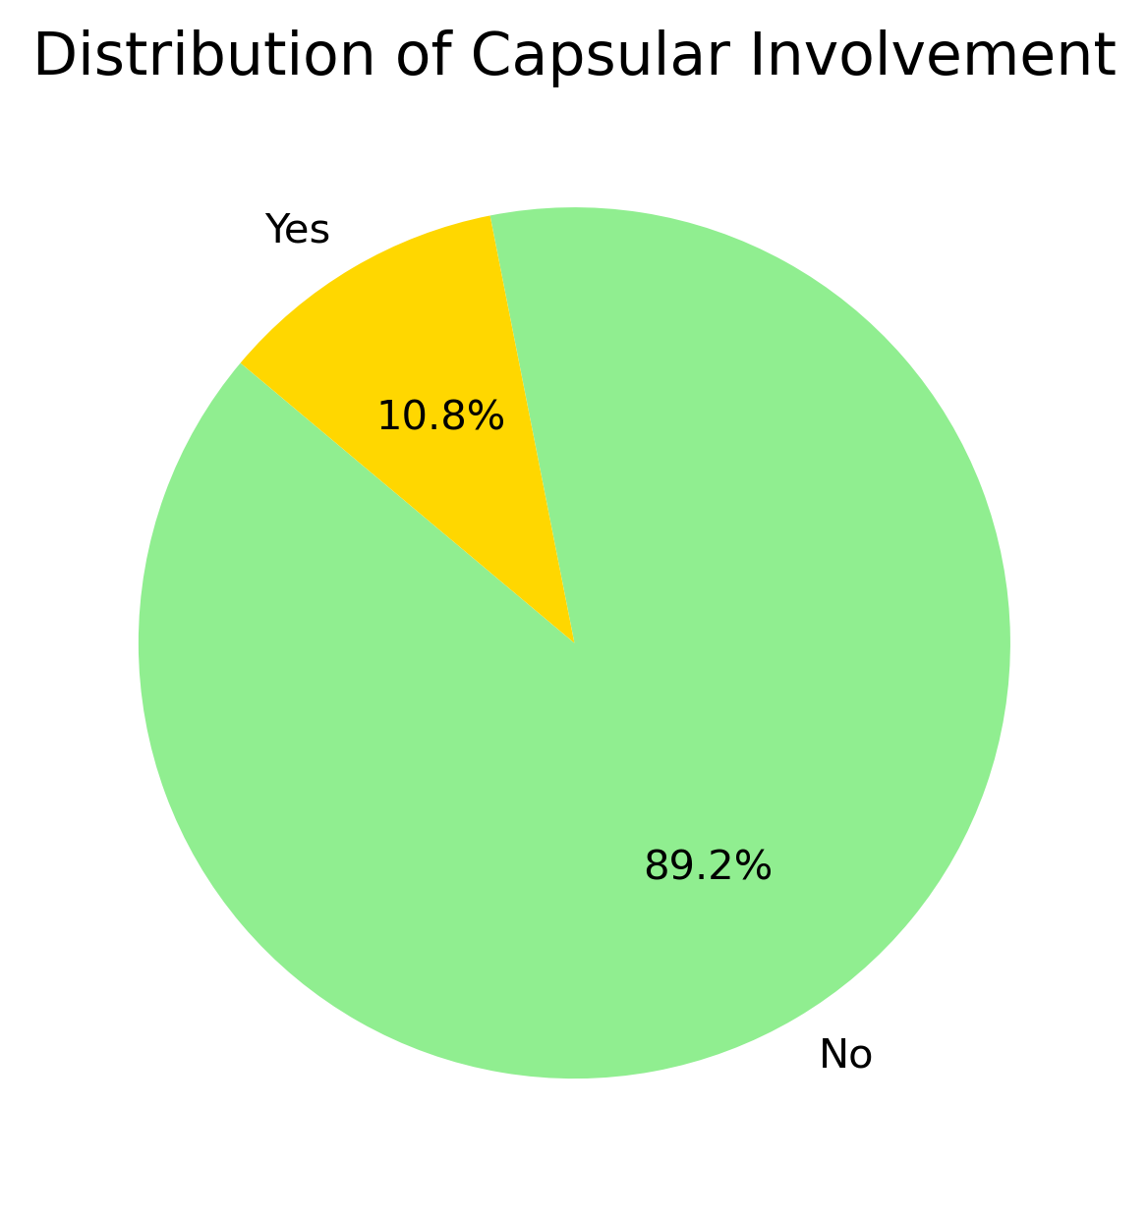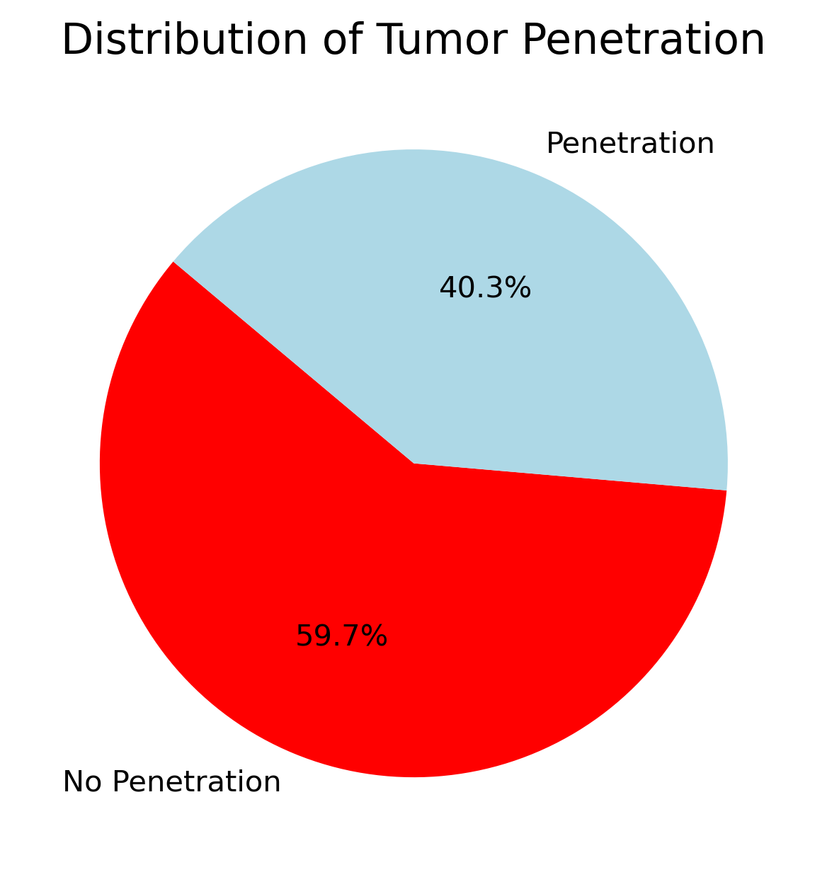

Figure 5

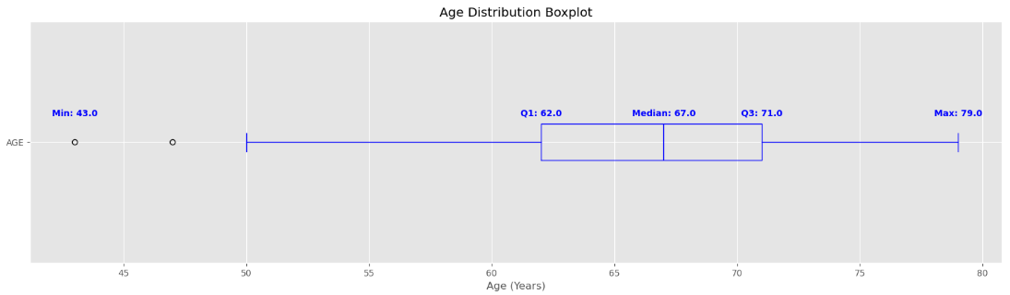
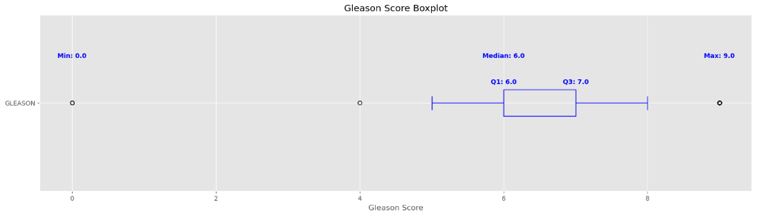

Figure 6
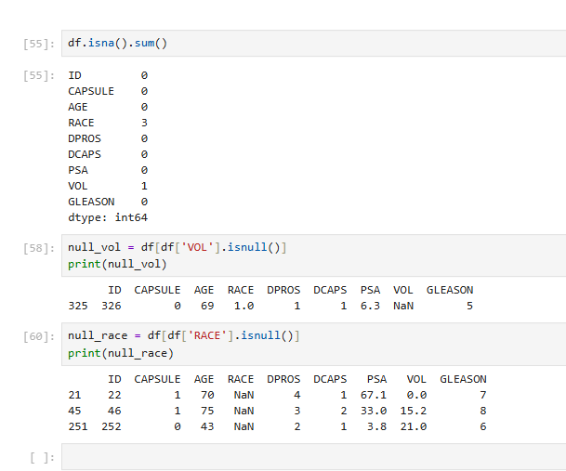

Figure 7
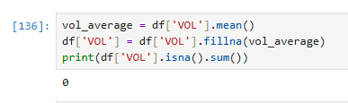

Codes for Visualizations:
VOL Histogram
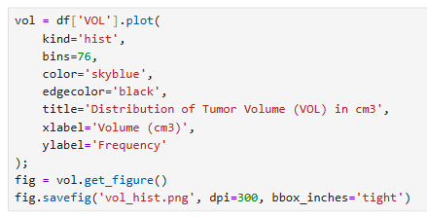
PSA Histogram
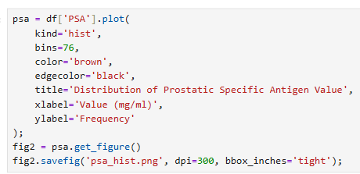
DPROS Bar Chart
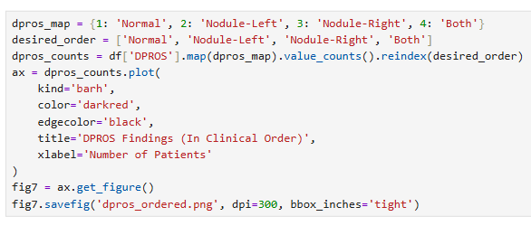
RACE Pie Chart
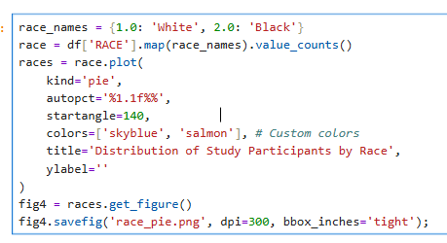
DCAPS Pie Chart
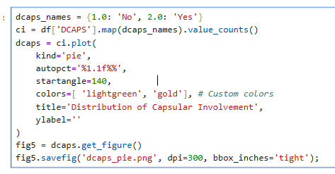
CAPSULE Pie Chart
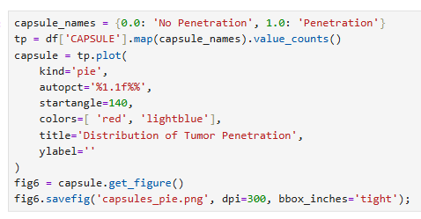

AGE Boxplot
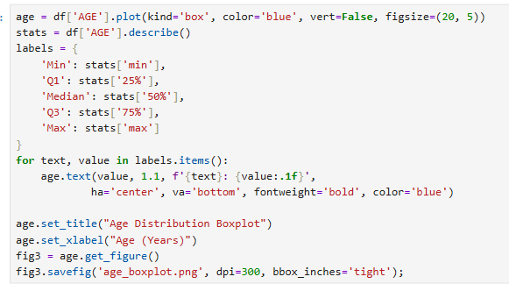

GLEASON Boxplot
